Arduino Weather Station with LCD Screen

TEJ4M – Mr. Thorne

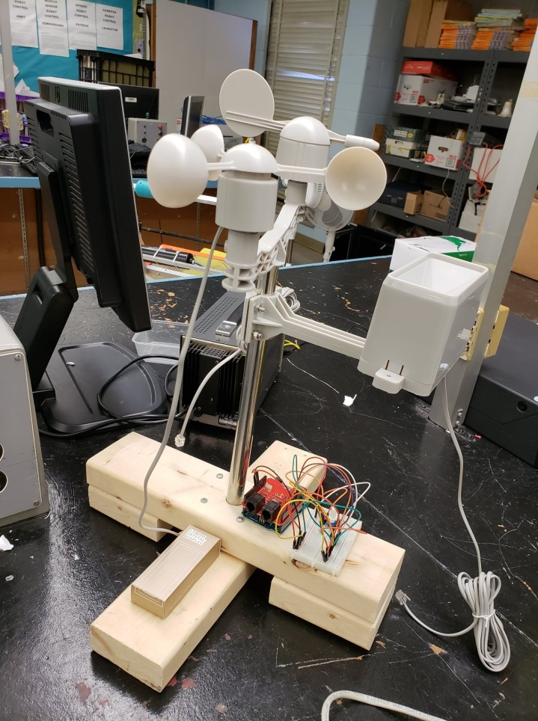

David Tran

**Equipment**

* **Arduino UNO**

An open source microcontroller board that is based on the Microchip ATmega328P and was developed by Arduino.cc. It contains 14 digital pins from 0 – 13, 6 analog pins from A0 – A5, a 16 MHz resontator, USB Port, power jack, and ICSP header. This board can be used in conjuction with the Arduino IDE, this allows it to be programmed to perform different functions.

* **Sparkfun Weather Shield**

Modular circuit board that is connected to the Arduino board, it looks like a shield for the board hence the name “Weather Shield”. The Sparkfun Weather Shield utilizes the HTU21D (now Si7021) humidity/temperature sensor and the MPL3115A2 altitude and Pressure sensor. These sensors are used with the Arduino Libraries that have the same name. RJ11 6-pin connectors can be soldered onto Shield to be used with the SEN-08942 Weather Station.

* **Sparkfun SEN-08942 Weather Station**

Attachment used along side the Sparkfun Weather Shield, contains a anemometer to track wind speed, self-emptying rain-gauge to track the amount of rain that has fallen and a wind vane to track direction of wind. It is connected to the Weather Shield through RJ11 6-pin connectors.

* **Arduino Liquid Crystal LCD Display**

2x16 LCD display that is connected to an Arduino board via breadboard and jumper wires. Uses 16 pins, a RS pin, Read/Write pin, Enable pin, 8 data pins (D0 – D7), Vo pin, +5V pin, GND pin, LED+ pin and LED- pin.

* Breadboard
* 10kΩ Potentiometer
* Jumper Wires

**Procedure**

Please refer to guide: <https://learn.sparkfun.com/tutorials/arduino-weather-shield-hookup-guide-v12>

**Software**

* Download the Sparkfun HTU2D1(legacy), Sparkfun MPL3115A2 and SparkFun Si7021 Libraries using Arduino Library Manager
* Download the LCD Weather Station program from: https://github.com/dtran001/DTran/blob/master/LCD_Weather_Station.ino
* Connect the Arduino board to computer and upload the program to the board
* Open the Serial Monitor

**Hardware**

* Solder the 2 RJ11 6-pin connectors onto the Weather shield
* Attach the Sparkfun Weather Shield onto the Arduino UNO board 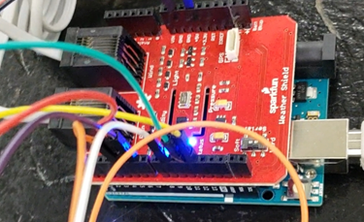
* Connect the Liquid Crystal LCD Display and 10kΩ potentiometer to breadboard
* Use jumper wires to connect the Arduino UNO and Sparkfun Weather Shield to breadboard in this configuration:

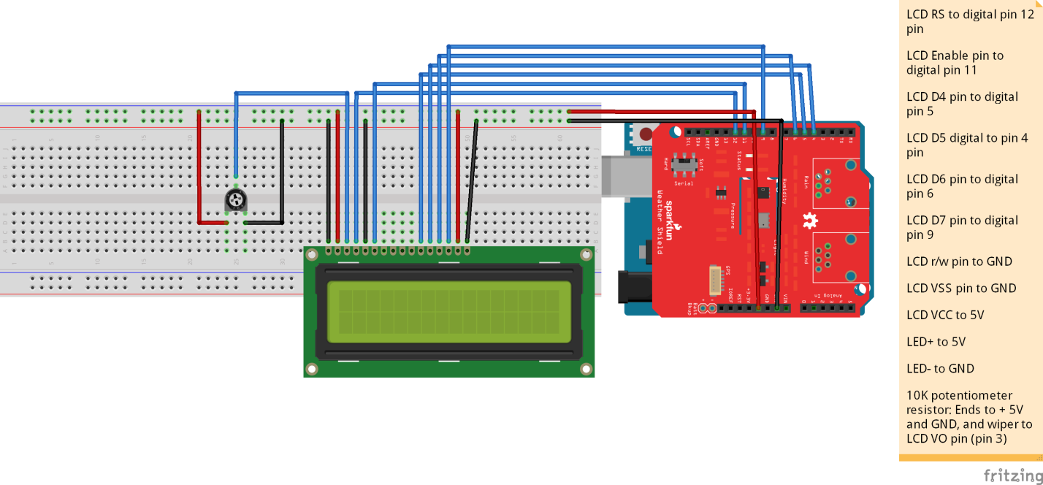

Figure 1 - Diagram of Wiring for the Liquid Crystal LCD Display

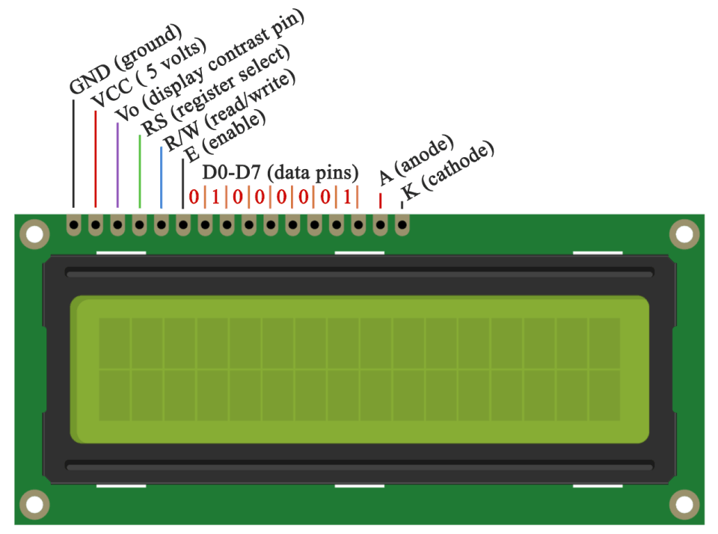

Figure 2 - Pins of the Liquid Crystal LCD Display

**Problems and Solutions**

1. **Problem:** Unable to install the proper libraries in order to make program work correctly.

**Solution:** Connect to Wi-Fi to download proper program required and install proper libraries using the built-in Arduino “Manage Libraries” Menu.

1. **Problem:** When trying to install Liquid Crystal LCD Display, problems with programming caused problems with the LCD display not showing the proper information.

**Solution:** Needed to find various guides about using the Liquid Crystal LCD Display and learning how to manipulate the original program and use and create function declarations using “void” and assigning the correct pins in the program.

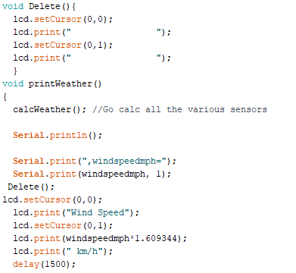

Figure 3 - "void Delete()" is a Function Used to Clear the Display

1. **Problem:** Unable to install Liquid Crystal LCD Display due to lack to knowledge on the pins and unable to wire the display correctly.

**Solution:** Required me to find the information for the LCD Display pins (Figure 2) and guides on how to install the Liquid Crystal LCD Display.

**Applications**

**Weather Station in Garden**

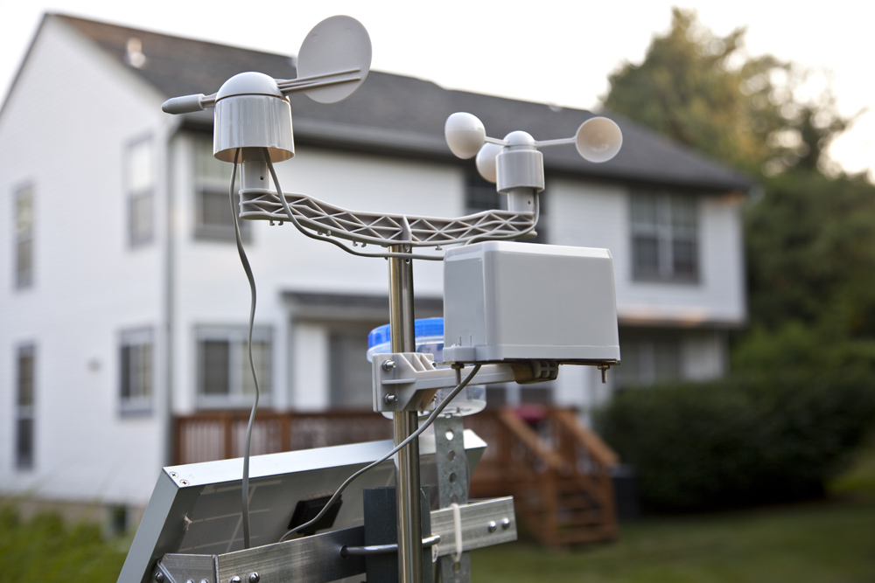

This Weather Station can be used in a garden in order to track the weather conditions of the garden to have the best conditions for plants in the garden, it is able to keep track of amount of rain that has fallen in x amount of time, the amount of sunlight that is shining onto the plants, humidity percentage, etc.

**In-Home Humidity Tracker**

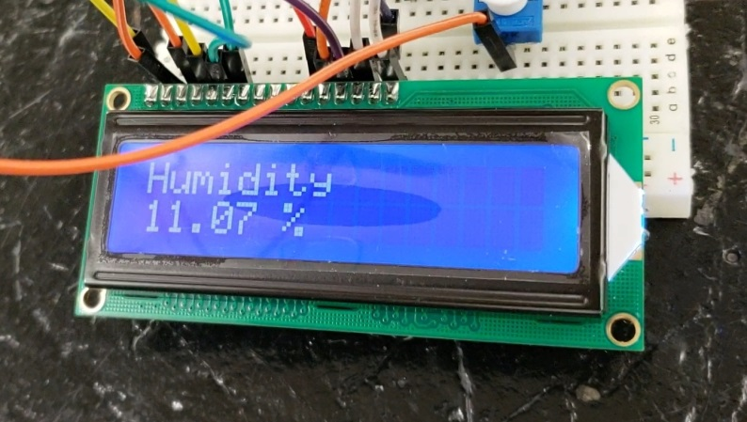

Tracking the humidity inside your home is important for our health; the Sparkfun Weather Shield contains a built-in humidity tracker that can track the percentage of humidity in the area. Keeping track of humidity is important, if there is too much humidity in our homes, there is a higher chance of mould, condensation and musty smells. If the humidity in our homes is too low, this could lead to dry throats, dry skin and chapped lips, etc.

**Personal Weather Station** 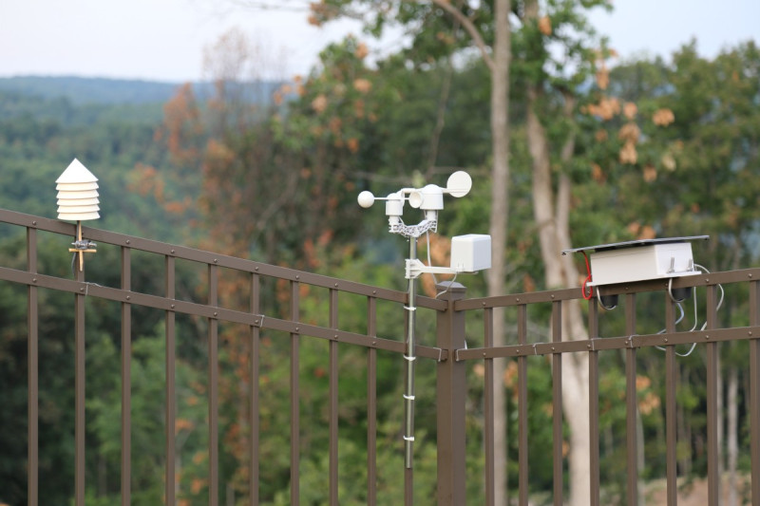

Tired of relying on the news to find out about the weather? The Sparkfun Weather Station can be used as your own personal way of knowing the exact weather in your specific area! This Weather Station allows you to know the exact weather condition for your local area instead of wide range area like the news would tell you!